**Project Design Phase- II**

**Data Flow Diagram & User Stories**

|  |  |
| --- | --- |
| Date | 20 October 2022 |
| Team ID | PNT2022TMID4719 |
| Project Name | Industry-Specific Intelligent Fire Management  System |

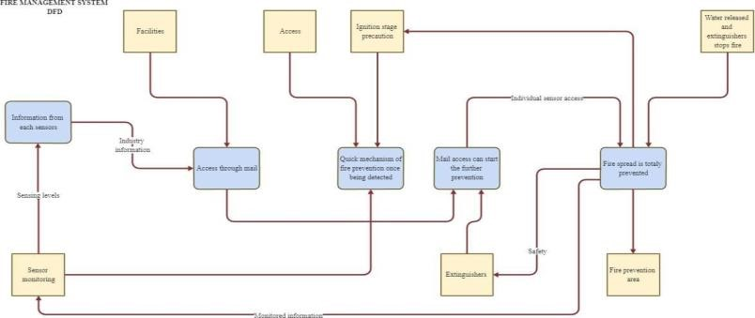

**User Stories**

|  |  |  |  |  |  |  |
| --- | --- | --- | --- | --- | --- | --- |
| **User Type** | **Functional requirement** | **User story number** | **User story/task** | **Acceptance criteria** | **Priority** | **Release** |
| Customer | Registration | USN-1 | As a user, I | I can access | High | Sprint-1 |
| (Mobile user, |  |  | can register | my account/ |  |  |
| Web user, |  |  | for the | dashboard |  |  |
| Care |  |  | application |  |  |  |
| executive, |  |  | by entering |  |  |  |
| Administrator) |  |  | my mail,  password, and  confirming my password |  |  |  |
|  |  | USN-2 | As a user, I | I can receive | High | Sprint-1 |
|  |  |  | will receive | confirmation |  |  |
|  |  |  | confirmation | email & click |  |  |
|  |  |  | email once I have  registered for the application | confirm |  |  |
|  | Dashboard | USN-3 | As a user, I | I can register | Low | Sprint-2 |
|  |  |  | can register | & access the |  |  |
|  |  |  | for the | dashboard |  |  |
|  |  |  | application | with Internet |  |  |
|  |  |  | through internet | login |  |  |
|  |  | USN-4 | As a user, I | I can confirm | Medium | Sprint-1 |
|  |  |  | can register | the |  |  |
|  |  |  | for the | registration in |  |  |
|  |  |  | application  through  Gmail | Gmail |  |  |
|  | Login | USN-5 | As a user, I | I can login | High | Sprint-1 |
|  |  |  | can log into | with my id |  |  |
|  |  |  | the  application  by entering email & password | and password |  |  |